Progress Report
Phase 6: eNTRy Rule Extension — Gram-Negative Permeation Descriptors
Helmholtz Centre for Infection Research (HZI)
1. Objective
Phase 5 established a high-performing model achieving AUPRC = 0.646 and P@10 = 0.90 using a 4,480-dimensional feature vector (ECFP4 binary+count, MACCS keys, RDKit 2D descriptors). SHAP analysis identified charge distribution and electronic surface descriptors as the dominant predictive features, consistent with the electrostatic importance of E. coli outer membrane permeability.
Phase 6 was motivated by the suggestion to incorporate the eNTRy rules (Richter et al., Nature 2017), a framework by the Hergenrother Laboratory to predict whether a small molecule can accumulate inside Gram-negative bacteria. Was also asked for descriptors such as TPSA and logP to evaluate compound uptake propensity. The core question is: of the compounds predicted active by the model, which ones can actually enter E. coli to reach their intracellular target?
The acronym eNTRy is formed from three rule letters N, T, R, lowercase 'e' and 'y' are cosmetic additions to spell a recognisable word and do not represent additional conditions. The three rules are:
Letter | Property | Condition for Gram-negative accumulation
N | Ionizable Nitrogen | Primary amine (NH₂ on sp³ carbon, non-sterically hindered)
T | Low Three-dimensionality | Globularity ≤ 0.25 (flat/rod-like, not spherical)
R | Rigidity | Rotatable bonds ≤ 5

Phase 6 was structured into three sequential steps, each building on the previous:
- Step 1: Compute eNTRy descriptors + TPSA/logP for all 2,334 molecules
- Step 2: Add these descriptors to the Phase 5 feature matrix and retrain models — do they improve AUPRC?
- Step 3 (ablation): Train on eNTRy descriptors only — how much standalone signal do they carry?
- Step 4 (filter): Apply eNTRy as a post-prediction filter — which top-ranked compounds can actually enter E. coli?
2. Input Data
File | Contents
smiles_labels_valid.csv | 2,334 validated SMILES strings with binary activity labels (Phase 2)
results_phase5/data/X_features.npy | Phase 5 feature matrix (2,334 × 4,480)
results_phase5/data/y.npy | Binary label vector (120 actives, 2,214 inactives)
results_phase5/data/scaffold_split.npz | Exact train/test indices from Phase 5 stratified scaffold split

The Phase 5 scaffold split was reused without modification across all experiments. This is essential: AUPRC comparisons between phases are only valid when the same molecules appear in the test set.
3. Step 1; eNTRy + Physicochemical Descriptor Calculation
3.1 Descriptors Computed
Ten new descriptors were computed for every SMILES string using RDKit and a port of the Hergenrother entry-cli logic. These fall into two groups:
Descriptor | Type | Description
has_primary_amine | 2D / binary | SMARTS match for NH₂/NH₃⁺ on sp³ carbon (Hergenrother definition)
rotatable_bonds | 2D / integer | Hergenrother definition: excludes amide N-C, terminal, and ring bonds
logP | 2D / continuous | Crippen logP — lipophilicity, governs passive membrane diffusion
TPSA | 2D / continuous | Topological Polar Surface Area — correlates with membrane permeability
glob_hergenrother | 3D / continuous | Ratio of smallest to largest eigenvalue of atomic coord covariance matrix
spherocity | 3D / continuous | RDKit SpherocityIndex (0 = flat, 1 = spherical) — compared to Hergenrother
asphericity | 3D / continuous | Deviation from perfect sphere
npr1, npr2 | 3D / continuous | Normalised principal moment ratios (shape triangle)
radius_of_gyration | 3D / continuous | Molecular size in 3D space
pbf | 3D / continuous | Plane of Best Fit: avg atom distance to best-fit plane (Å)
passes_eNTRy | Derived / binary | 1 if has_primary_amine AND rot_bonds ≤ 5 AND glob ≤ 0.25

3.2 HPC Computation
Metric | Value
Total molecules processed | 2,334
3D embedding failures | 1 (0.04%) — filled with column medians
Conformers per molecule | 10 (MMFF-optimised, ETKDGv3)
Wall-clock time | 3 min 25 sec (16 cores, HAICORE KIT)
Output | entry_descriptors.csv (2,334 × 22 columns)

4. Biological Validation; eNTRy Enrichment and Globularity Comparison
4.1 eNTRy Pass Rate by Class
Class | Total | Passing eNTRy | Pass Rate
Active (label = 1) | 120 | 7 | 5.8%
Inactive (label = 0) | 2,214 | 93 | 4.2%
Total | 2,334 | 100 | 4.3%

The enrichment is negligible (5.8% vs 4.2%). This is biologically coherent: the eNTRy rules predict accumulation via a specific passive permeation mechanism, but the Stokes dataset measures growth inhibition of E. coli BW25113, capturing many mechanisms including membrane disruption, efflux pump interactions, and intracellular target binding. Many actives likely operate through routes other than Hergenrother-style accumulation.
4.2 Globularity Definition Comparison
The Pearson correlation between Hergenrother globularity (PCA eigenvalue ratio) and RDKit SpherocityIndex across all 2,333 valid molecules was r = 0.961. The two definitions are effectively interchangeable. Figure 1 shows the scatter plot — actives (orange) and inactives (blue) are interspersed throughout the globularity range with no visible separation at the eNTRy threshold (dashed red).
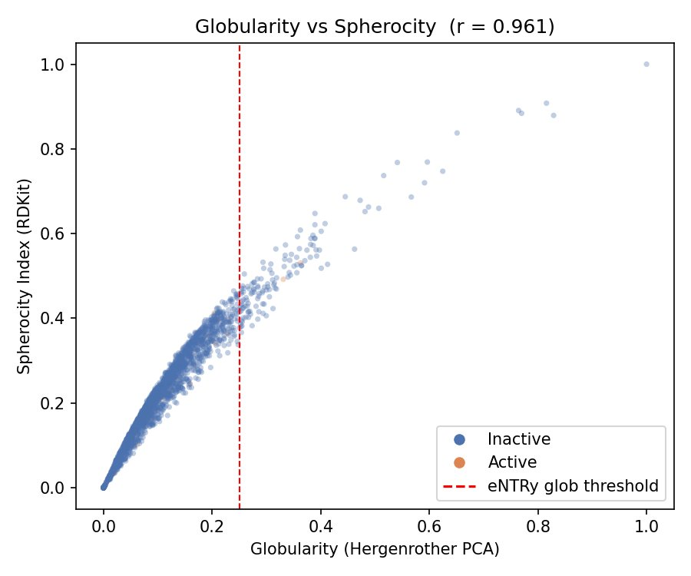
Figure 1. Hergenrother globularity vs RDKit SpherocityIndex (r = 0.961). Red dashed line = eNTRy globularity threshold of 0.25. Orange = active, blue = inactive.
5. Step 2 — Model Integration (Extended Features)
5.1 Approach
The 10 eNTRy/3D descriptors were appended to the Phase 5 feature matrix (4,480-dim) producing an extended matrix of 4,490 dimensions. Phase 5 best hyperparameters were used without re-tuning, so any performance difference is attributable solely to the new features.
5.2 Results
Model | Phase 5 AUPRC | Phase 6 AUPRC | Delta | ROC-AUC | P@10
XGBoost (tuned) | 0.6415 | 0.6204 | −0.0211 | 0.9089 | 0.80
LightGBM (tuned) | 0.6522 | 0.6189 | −0.0333 | 0.9153 | 0.70
Random Forest | 0.6253 | 0.6081 | −0.0172 | 0.9190 | 0.80
Logistic Regression | 0.4783 | 0.4786 | +0.0003 | 0.8116 | 0.70
Ensemble (avg) | 0.6085 | 0.5938 | −0.0147 | 0.8735 | 0.80

Adding the 10 eNTRy features caused a small but consistent AUPRC decrease for all tree-based models. This is a known high-dimensional feature dilution effect: weakly informative features appended to a large matrix can redirect tree splits away from established informative features. The features are not uninformative in isolation — as the ablation study (Section 6) shows — but they are diluted at a ratio of 10 new features among 4,490 total.
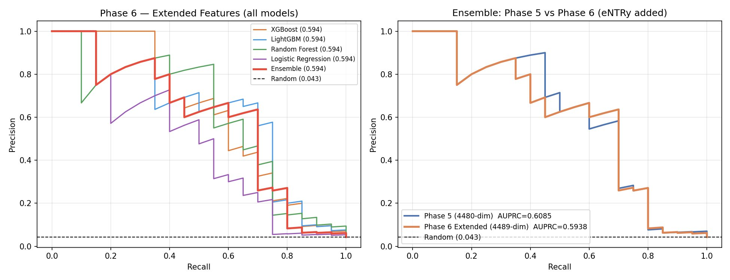
Figure 2. Left: PR curves for all models with extended features. Right: Head-to-head ensemble comparison, Phase 5 vs Phase 6 extended.
6. Step 3 — eNTRy Descriptors Only (Ablation Study)
6.1 Motivation and Results
To quantify standalone predictive power of the eNTRy framework, models were trained using only the 10 eNTRy/3D descriptors — no fingerprint information. This directly answers: how much does the permeation-based feature set predict antibacterial activity on its own?
Experiment | # Features | AUPRC | ROC-AUC | P@10
Phase 5 best (stacking ensemble) | 4,480 | 0.6460 | 0.9188 | 0.90
Phase 4 baseline (ECFP only, valid split) | 2,048 | 0.6125 | 0.9198 | 0.80
Phase 6 extended (+eNTRy, ensemble) | 4,490 | 0.5938 | 0.8735 | 0.80
eNTRy only — XGBoost | 10 | 0.2456 | 0.6666 | 0.40
eNTRy only — Random Forest | 10 | 0.2279 | 0.6456 | 0.40
eNTRy only — Logistic Regression | 10 | 0.1600 | 0.7180 | 0.10
Literature benchmark (Lin et al. 2025) | — | 0.4500 | — | —
Random baseline | — | 0.0427 | — | —

The eNTRy descriptors carry genuine but limited standalone signal: AUPRC = 0.25 vs a random baseline of 0.04 (approximately 6× above chance with just 10 features). However, fingerprint-based models outperform eNTRy-only models by 2.5× in AUPRC (0.61 vs 0.25), reflecting the fundamental difference in information content: fingerprints encode target-binding potential while eNTRy encodes membrane permeation propensity.
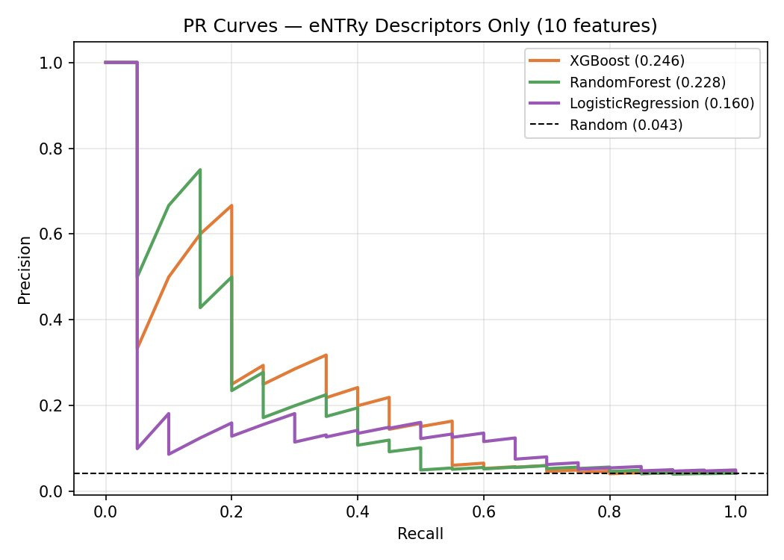
Figure 3. PR curves for models trained on eNTRy descriptors only (10 features). AUPRC = 0.25 for XGBoost vs 0.04 random baseline — 6× above chance.
7. SHAP Feature Importance
SHAP analysis on the tuned XGBoost model (extended 4,490-dim features) shows where the eNTRy descriptors rank among all features. None of the eNTRy features appear in the top 30 — the dominant features are all Phase 5 physicochemical descriptors (feat_4XXX = RDKit 2D block). The eNTRy features rank as follows:
eNTRy Feature | SHAP Rank (of 4,490) | Interpretation
radius_of_gyration | 36 | Highest-ranked; 3D molecular size is predictive
pbf | 55 | High; molecular flatness carries signal
npr2 | 74 | Moderate; principal moment shape descriptor
npr1 | 80 | Moderate
asphericity | 82 | Moderate; deviation from spherical shape
spherocity | 86 | Moderate; RDKit shape measure
glob_hergenrother | 97 | Moderate; Hergenrother globularity
rotatable_bonds | 175 | Low; molecular flexibility
has_primary_amine | 322 | Very low; consistent with weak class enrichment
passes_eNTRy | 390 | Near-noise; binary flag adds little over its components

3D shape descriptors (radius of gyration, PBF, NPR1/2) consistently outrank the amine flag and the binary eNTRy pass indicator. Continuous molecular shape information is more informative than the discrete rule-based classification for this task.
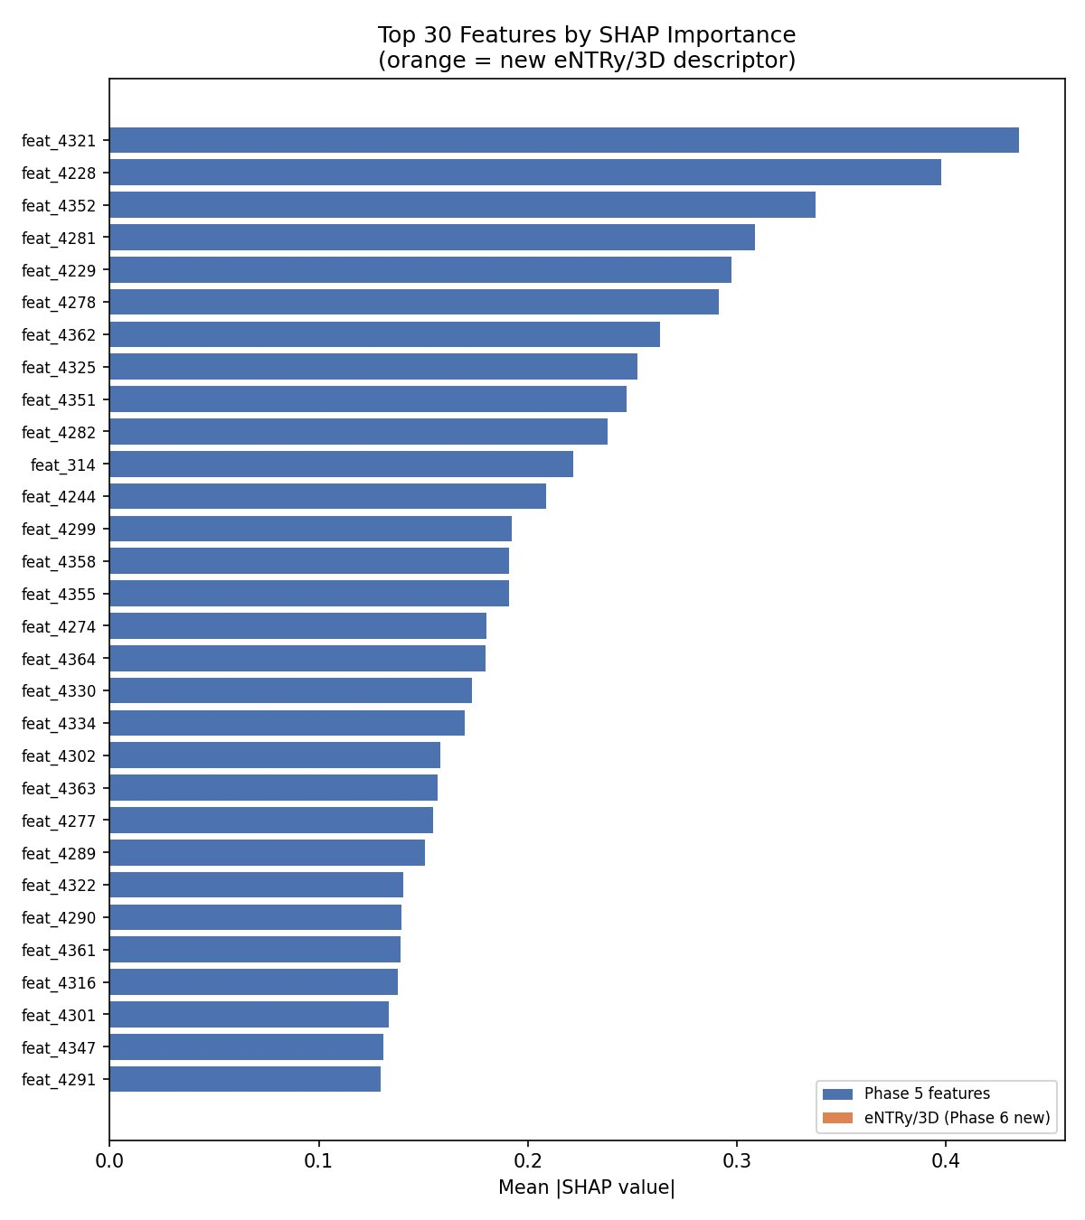
Figure 4. SHAP feature importance for the extended XGBoost model (top 30 features). All top 30 are Phase 5 features (blue); no eNTRy/3D descriptor (orange) appears in the top 30.
8. Step 4 — eNTRy as a Post-Prediction Filter
8.1 Motivation
This step addresses the core question directly: of the compounds the model ranks highest as predicted actives, which ones are also likely to accumulate inside E. coli? A compound that is both predicted active and passes the eNTRy rules is a higher-confidence candidate for wet-lab testing, as it must satisfy both: (1) structural features associated with antibacterial activity, and (2) physicochemical properties enabling Gram-negative cell entry.
8.2 Filter Results — Top 50 Predictions
Metric | Value | Interpretation
True actives in top 50 | 15 / 50 (30%) | 7× above random (4.3% baseline) — model is highly enriched
Passing eNTRy rules | 2 / 50 (4%) | Very few top predictions pass strict eNTRy criteria
Priority candidates | 2 / 50 | Predicted active AND passes eNTRy (both are true negatives)
TPSA ≤ 140 Å² | 21 / 50 (42%) | Less than half have membrane-permeable TPSA
logP in [−2, 6] | 31 / 50 (62%) | Most have acceptable lipophilicity range
eNTRy pass rate: top 50 vs rest | 4.0% vs 1.0% | 4× enrichment — model does push eNTRy-compatible compounds higher

Critically, neither of the two priority candidates (rank 27 and 32) are true actives — both are false positives. Furthermore, none of the 15 confirmed actives in the top 50 pass the strict eNTRy rules. This is the most important finding of the extension: the compounds the model identifies as active operate through mechanisms other than Hergenrother-style passive accumulation.
The two priority candidates are anthracycline-like structures (TPSA ~185-206 Å², logP ~0.4-1.5, globularity ~0.08) that pass eNTRy shape-wise but have high TPSA values raising an additional permeability concern.
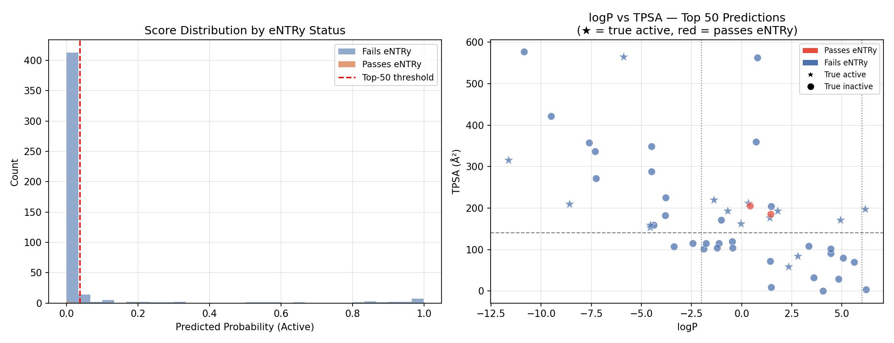
Figure 5. Left: Score distribution coloured by eNTRy status — compounds passing eNTRy (orange) are rare across all score ranges. Right: logP vs TPSA for top-50 predictions (★ = true active, red = passes eNTRy). True actives span a wide physicochemical space with no clustering in the eNTRy-favourable region.
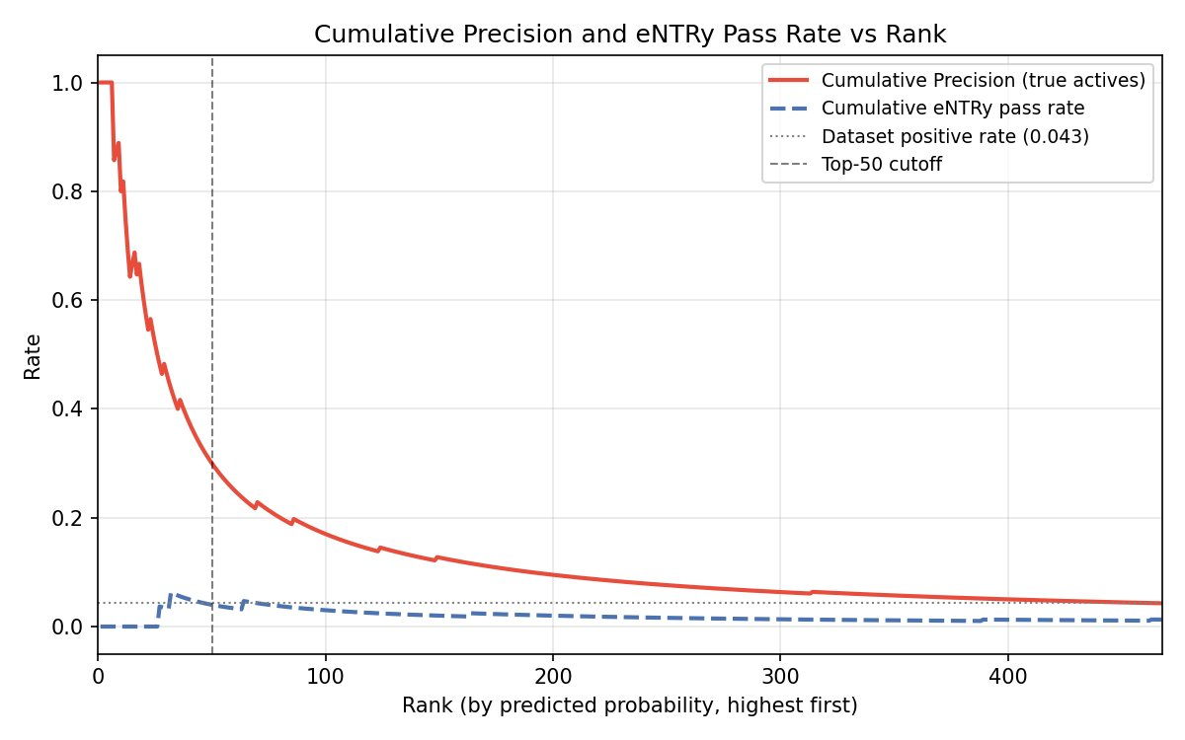
Figure 6. Cumulative precision (red) declines from 1.0 at rank 1 to 0.30 at rank 50, still far above the 4.3% dataset baseline. Cumulative eNTRy pass rate (blue dashed) remains near zero throughout, confirming that the model's top predictions are driven by structural, not permeation-based, features.
9. Summary of All Findings
Research Question | Finding
Do 3D shape descriptors improve AUPRC? | No improvement when added to Phase 5 matrix — small consistent decrease due to feature dilution. But they carry real standalone signal (6× above chance with 10 features alone).
How much do eNTRy descriptors predict alone? | AUPRC = 0.25 (XGBoost, 10 features) vs 0.04 random. Meaningful but 2.5× below fingerprint models.
Do Hergenrother glob and RDKit spherocity agree? | Yes — Pearson r = 0.961. Effectively interchangeable on this dataset.
Do actives pass eNTRy at a higher rate? | Negligible enrichment: 5.8% actives vs 4.2% inactives. Dataset captures diverse mechanisms.
Which top predictions can enter E. coli (supervisor's question)? | Only 2/50 top predictions pass eNTRy — and neither is a true active. The model's confirmed actives operate through mechanisms other than Hergenrother-style passive accumulation.
What is the best SHAP-ranked eNTRy feature? | radius_of_gyration (rank 36/4,490) — 3D molecular size carries the most permeation-relevant signal.

10. Outputs
File | Contents
entry_descriptors.csv | 2,334 × 22: all eNTRy and 3D shape descriptors per molecule
results_phase6/X_extended.npy | Extended feature matrix (2,334 × 4,490)
results_phase6/ranked_predictions.csv | All 468 test compounds ranked by predicted probability with eNTRy descriptors
results_phase6/priority_candidates.csv | 2 compounds: predicted active AND passing eNTRy rules
results_phase6/results_phase6.json | Model integration metrics and SHAP ranks
results_phase6/results_phase6b.json | eNTRy-only ablation metrics
results_phase6/results_phase6c.json | eNTRy filter analysis on top-50 predictions
results_phase6/figures/glob_vs_spherocity.png | Globularity vs Spherocity scatter (r = 0.961)
results_phase6/figures/pr_curves_phase6.png | PR curves: Phase 5 vs Phase 6 extended features
results_phase6/figures/pr_curves_entry_only.png | PR curves: eNTRy descriptors only
results_phase6/figures/shap_phase6.png | SHAP importance: top 30 features
results_phase6/figures/entry_filter_top50.png | Score distribution and logP/TPSA scatter for top-50 predictions
results_phase6/figures/cumulative_precision_entry.png | Cumulative precision and eNTRy pass rate vs rank

11. Conclusion
Phase 6 systematically applied the Hergenrother eNTRy rules to the antibiotic activity prediction pipeline in three complementary ways: as additional ML features, as standalone predictors, and as a post-prediction filter.
The eNTRy descriptors encode genuine physicochemical signal, 6× above random with 10 features alone but do not improve the Phase 5 model when appended to a 4,480-dimensional feature matrix. The most informative eNTRy-derived features are continuous 3D shape descriptors (radius of gyration, PBF, NPR1/2) rather than the discrete primary amine flag or binary passes_eNTRy indicator.
The post-prediction filter directly answered the question: of the top 50 model predictions, only 2 pass the eNTRy rules, and neither is a confirmed active. The 15 true actives in the top 50 do not pass eNTRy, indicating they are active through diverse mechanisms — target engagement, membrane disruption, or alternative uptake routes rather than the specific Hergenrother passive accumulation pathway.
The best model from Phase 5 (AUPRC = 0.646, P@10 = 0.90) remains the recommended model for compound prioritisation. Phase 6 adds a validated permeation descriptor pipeline and a biologically interpretable analysis confirming that the Stokes E. coli dataset captures a broader activity landscape than the eNTRy framework was designed for.
Phase 6 Progress Report | HZI Antibiotic Discovery Project

